Iman Abdalla
Agentic Ai
03/22/26
Final Project: Project Milestone 2 - Multi-agent workflow

Code

import express, { type Request, Response, NextFunction } from "express";
import { registerRoutes } from "./routes";
import { serveStatic } from "./static";
import { createServer } from "http";

const app = express();
const httpServer = createServer(app);

declare module "http" {
interface IncomingMessage {
rawBody: unknown;
}
}

app.use(
express.json({
verify: (req, _res, buf) => {
req.rawBody = buf;
},
}),
);

app.use(express.urlencoded({ extended: false }));

export function log(message: string, source = "express") {
const formattedTime = new Date().toLocaleTimeString("en-US", {
hour: "numeric",
minute: "2-digit",
second: "2-digit",
hour12: true,
});

console.log(`${formattedTime} [${source}] ${message}`);
}

app.use((req, res, next) => {
const start = Date.now();
const path = req.path;
let capturedJsonResponse: Record<string, any> | undefined = undefined;

const originalResJson = res.json;
res.json = function (bodyJson, ...args) {
capturedJsonResponse = bodyJson;
return originalResJson.apply(res, [bodyJson, ...args]);
};

res.on("finish", () => {
const duration = Date.now() - start;
if (path.startsWith("/api")) {
let logLine = `${req.method} ${path} ${res.statusCode} in ${duration}ms`;
if (capturedJsonResponse) {
logLine += ` :: ${JSON.stringify(capturedJsonResponse)}`;
}

log(logLine);
}
});

next();
});

(async () => {
await registerRoutes(httpServer, app);

app.use((err: any, _req: Request, res: Response, next: NextFunction) => {
const status = err.status || err.statusCode || 500;
const message = err.message || "Internal Server Error";

console.error("Internal Server Error:", err);

if (res.headersSent) {
return next(err);
}

return res.status(status).json({ message });
});

// importantly only setup vite in development and after
// setting up all the other routes so the catch-all route
// doesn't interfere with the other routes
if (process.env.NODE_ENV === "production") {
serveStatic(app);
} else {
const { setupVite } = await import("./vite");
await setupVite(httpServer, app);
}

// ALWAYS serve the app on the port specified in the environment variable PORT
// Other ports are firewalled. Default to 5000 if not specified.
// this serves both the API and the client.
// It is the only port that is not firewalled.
const port = parseInt(process.env.PORT || "5000", 10);
httpServer.listen(
{
port,
host: "0.0.0.0",
reusePort: true,
},
() => {
log(`serving on port ${port}`);
},
);
})();

// ===== MULTI AGENT SYSTEM =====
function plannerAgent(userInput) {
return {
tasks: [
"Break assignment into smaller parts",
"Estimate time for each part",
"Schedule tasks"
],
originalRequest: userInput
};
}
function executorAgent(plan: any) {
return {
studyPlan: `
Day 1: Research topic (2 hours)
Day 2: Outline + writing (3 hours)
Day 3: Finish draft (2 hours)
Day 4: Review (1 hour)
`,
basedOn: plan
};
}
function criticAgent(execution: any) {
return {
improvedPlan: execution.studyPlan + "\n+ Add breaks and buffer time",
feedback: "Improved for better balance"
};
}

function runMultiAgentSystem(userInput: any) {
const plan = plannerAgent(userInput);
const execution = executorAgent(plan);
const result = criticAgent(execution);

return result;
}

console.log(runMultiAgentSystem("Plan my homework"));

Architecture Diagram

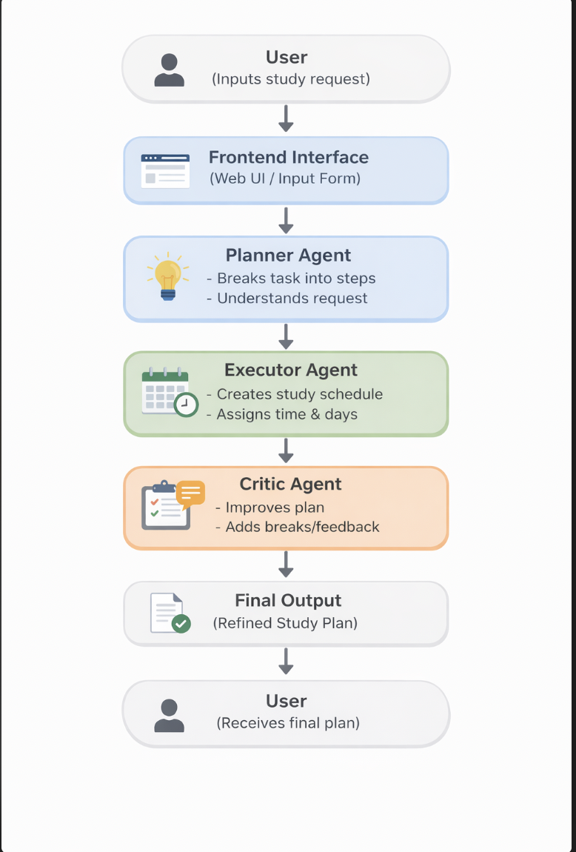
The Academic Planner Assistant is designed to help students organize their academic work into a structured study plan. When a user enters a request, the system processes it through multiple steps rather than completing everything at once. This approach allows the system to break down the task, create a plan, and then improve it before returning the final result. Each part of the system has a specific role, which makes the overall process more organized and effective. Instead of producing a quick response that may not be very detailed, the system takes its time to go through each stage so that the final output is more useful and realistic for the user.
The first part of the system is the planner agent. This agent takes the user’s input and focuses on understanding what needs to be done. Instead of creating a full schedule right away, it breaks the request into smaller tasks that are easier to manage. For example, if the user asks for help planning homework, the planner agent will identify steps such as researching, outlining, writing, and reviewing. This helps turn a general request into clear and specific actions. The planner agent also keeps the original request so that the rest of the system can stay aligned with what the user initially asked for. This step is important because it sets the foundation for everything that comes after, and if the task is not broken down correctly, the rest of the plan may not be as effective.
The next part is the executor agent, which takes the tasks created by the planner agent and turns them into a study schedule. This agent focuses on organizing the work across multiple days and assigning time to each task. Its goal is to create a clear and structured plan that the user can follow without feeling overwhelmed. For example, it might place research on the first day, writing on the next day, and reviewing at the end. By spreading the work out, the system helps the user manage their time better. The executor agent also makes sure that the plan is realistic and not too packed into one day. At this stage, the system produces a draft version of the study plan based on the earlier breakdown. This draft gives the user a solid starting point, even before any improvements are made.
After that, the critic agent reviews the plan created by the executor agent. Its purpose is to improve the quality of the schedule by making it more balanced and practical. It looks at the plan and considers whether the workload is reasonable and whether adjustments are needed. The critic agent may add breaks, adjust timing, or make small improvements to ensure the plan is manageable for the user. For example, it might suggest adding buffer time in case something takes longer than expected. It also provides short feedback explaining what was improved. This step is important because it helps refine the plan and makes it more realistic for everyday use. Without this step, the plan might still work, but it would not be as polished or user friendly.
All of the agents communicate in a sequence where the output of one becomes the input of the next. The user’s request is first processed by the planner agent, then passed to the executor agent, and finally reviewed by the critic agent. Once the process is complete, the final improved plan is sent back to the user through the interface. This step by step flow makes the system easier to understand and helps maintain consistency in the output. It also allows each agent to focus on a specific task without interfering with the others. Because of this structure, the system is more organized and easier to improve in the future if changes are needed.
The system also includes basic error handling to manage problems or low quality results. If an issue occurs, such as a server error or an unexpected input, the system returns a standard error message instead of failing completely. This helps prevent the application from crashing and keeps the experience more stable for the user. In terms of output quality, the use of multiple agents helps improve results because each stage has the opportunity to refine the work. Even if one step produces a simple result, the following step can enhance it before it reaches the user. This layered approach makes the final output more reliable and useful.
Another benefit of this system is that it is flexible and easy to expand. Since each agent has a specific role, new features can be added without changing the entire system. For example, an additional agent could be added in the future to personalize the schedule based on the user’s preferences or deadlines. This makes the system more adaptable and useful over time. It also allows developers to improve individual parts of the system without affecting the rest of the workflow.
Overall, the Academic Planner Assistant uses a multi agent structure to organize tasks, generate schedules, and improve results. By separating the process into different stages, the system produces clearer and more useful study plans while remaining easy to follow. This approach not only improves the quality of the output but also makes the system more reliable and easier to maintain.

Output :
